Background concentration of PFAS in Groundwater
L.H. Beem

Background concentration is either the naturally occurring ambient levels of contaminants in the environment or concentrations as the result of human-generated, non-site-related sources. As all PFAS compounds are synthetic, we are concerned with the later definition of anthropogenic non-site-related sources, such as atmospheric deposition of PFAS leaching to groundwater or distributive aquifer dynamics from dispersed land application of pfas contaminated fluids.
An estimate of the background values of contamination can be significant to determining the need or scope of mitigation efforts, as it may be unrealistic to expect a medium (e.g. groundwater) to ever have a concentration below background levels.
All the analysis below uses a compilation of LD1600 and non-LD1600 groundwater samples, of which there are approximately 4000 samples. These samples have not been controlled for quality-control evaluation, well type, well depth, or analytical methodology. A lack of control introduces an issue of what background values are estimated here. It is expected that groundwater near the water table would have a higher likelihood of contamination than water deep in the aquifer. Without controls on what depth in the aquifer the water sample represents, this analysis effectively flattens the aquifer and assumes consistency with depth. However, most wells in this data set are drilled and it is likely the analysis is more representative of intermediate or deep aquifer than the shallow aquifer.

Frequency of Non-Detect
The simplest methodology for determining a background level is to use the lowest concentrations detected as indicative of the background level. If these values are non-zero, bias in the sampling locations would need to be considered to ensure that site-specific conditions are not influencing what minimums are being detected. For this analysis, we are using non-detect as the presumptive background level. The fact that all the samples in this dataset are motivated by the existence or suspected existence of site-specific PFAS contamination creates an expected bias of higher concentrations within this dataset than would be observed from random sampling across the state. That many samples in this dataset return non-detect for most or all PFAS compounds may be the simplest and most compelling argument for non-detect being an accurate background concentration value.
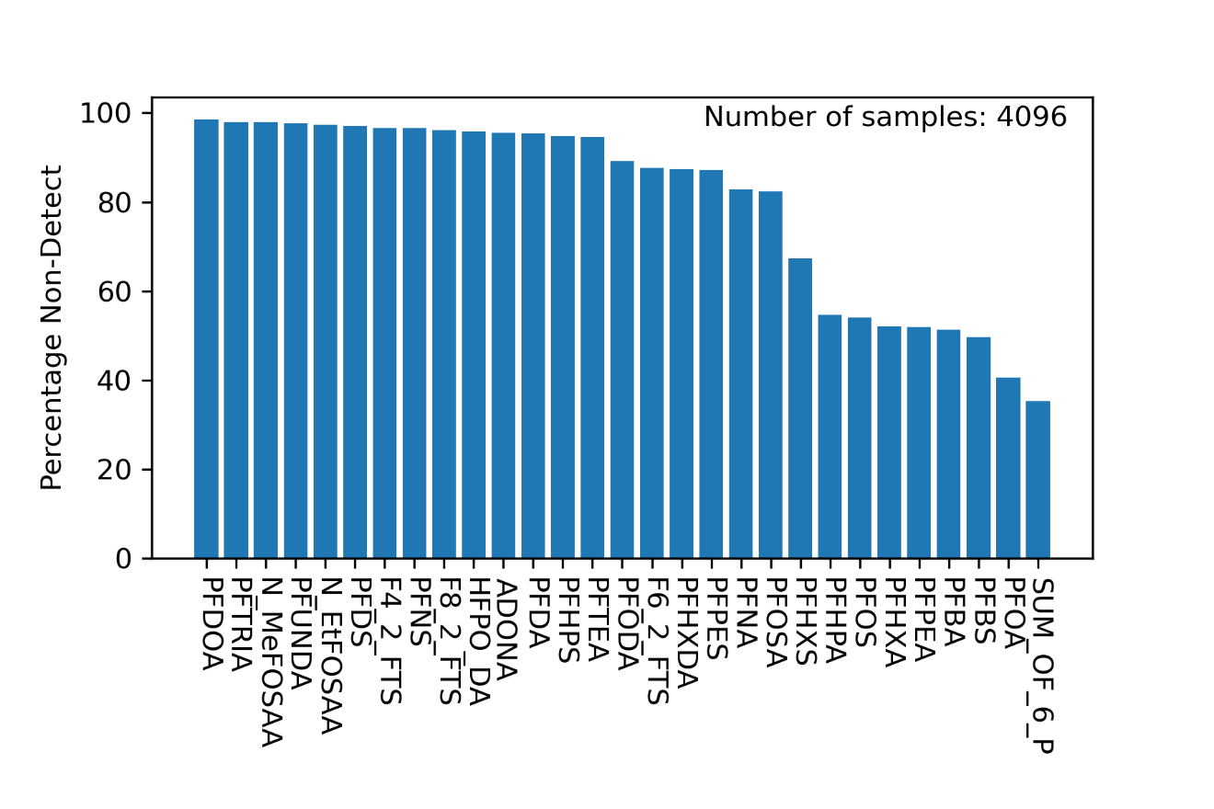
Figure 1: Percentage of samples that are non-detect for specific PFAS compounds and sum of 6.

The occurrence of any non-detect results suggests that background concentration is at the non-detect level. Figure 1 may demonstrate that a non-detect background is applicable for any PFAS compound. Certainly, if more than 98% of samples adjacent to or within sites of expected PFAS contamination are non-detect, as is the case for PFODA, a background of non-detect would be reasonably applied. PFOS is not detected in more than 54% of the samples. PFOA is not detected in more than 40% of samples. Even non-detect for sum of 6, which has the more stringent constraint of six separate compounds not being present in a sample, occurs in more than 35% of samples. A third of samples, should be adequate to demonstrate that finding non-detect levels of compounds is a common occurrence, especially given the expected bias of these samples coming from areas where contamination is reasonably expected.

Geographic Variability
Figure 2: Maps showing the geographic distribution of non-detect results for a) Sum of 6, b) PFOS, and c) PFOA.

It’s possible that there is regional variability of background level because of spatial heterogeneity in the depositional or distributive processes that influence background PFAS concentrations that would make a single statewide value inappropriate. Plotting the location of non-detect sample results shows that the geographic distribution of non-detect results are distributed across all regions where samples are present. There are no regions with many samples with detections (blue dots in figure 2) without some proximal non-detects (red dots in figure 2). There is bias of where PFAS groundwater samples exist, southern Maine and along the 95 corridor. This bias is related to population density and sludge distribution logistics.
To demonstrate the spatial concentration of site-related sources, all the samples in Fairfield, ME, where many of the highest PFAS concentration in groundwater exists, are analyzed. In Fairfield, 36% of samples are non-detect from PFOS, 17% are non-detect of PFOA, and 16% are non-detect for sum of 6.
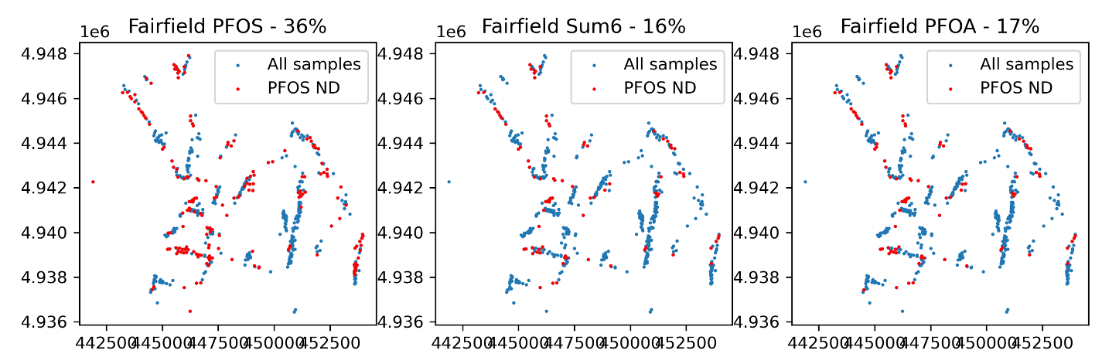
Figure 3. Prevalence of non-detect results in Fairfield, ME.

In an area of maximum PFAS impact, and using samples that collected through the expectation of higher risk from site-related contamination, non-detect samples are still found across the region. Finding background concentrations is more difficult in Fairfield than in other areas of the state, but the background values in Fairfield are likely to be non-detect.

Aquifer Mixing / representative distance
How representative a sample is to the broader aquifer is dependent on numerous physical processes and could be estimated in multiple ways. A conservative estimate is the volume from which a well physically draws water. This volume is related to a) the distance that is equal to the cone of depression of the well and b) advective-diffusive processes that mix an aquifer. However, a water sample can be representative of a volume/area from which it does not directly sample. For instance, if an aquifer is completely and instantaneously mixed, one sample anywhere would be representative of the entire volume. Of course, physical processes occur at a much slower rate, but estimating the mixing time or distance of the aquifer would inform the magnitude of a representative distance from a sample location that should be chemically consistent or, conversely, unimpacted by distributed land application of PFAS containing fluids.

Cone of Depression
The cone of depression is the area that physically feeds an extractive well. The removal of water lowers the head at the well location and causes water to flow towards the well from some distance away. The Theis equation applied to an unconfined aquifer can estimate what the distance is. The equation estimates the change in head (dh) at some distance (r) from the well location. The distance where dh sufficiently approaches zero can be taken as a representative distance. The change in head is a function of water flux out of the well (Q), the specific yield of the aquifer (S_{y}), and the hydraulic conductivity of the aquifer (K). T is transmissivity, W(u) is the exponential integral function, b is aquifer thickness that needs to be sufficiently larger than the magnitude of dh or the assumptions of the equation fail, and t is elapsed time.
$$dh=\frac{Q}{4πT}W(u)$$
$$T=\frac{K}{b}$$
$$u=\frac{r^{2}S_{y}}{4Tt}$$
The magnitude of the various parameters vary across the state. The physical properties of an aquifer range over many orders of magnitude. The amount of water used for a household can also vary by many factors. To find a representative cone of depression distance a Monte Carlo simulation, with 10⁵ solutions, was used to estimate the probability distribution function. Each parameter uses a uniform probability distribution. See Table 1 for parameter ranges used.
Parameter | Minimum | Maximum
Well Discharge (Q) | 100 gal/d | 500 gal/d
Hydraulic Conductivity (K) | 10⁻⁹ m/s | 10⁻⁴ m/s
Specific Yield (S_{y}) | 0.01 | 0.3
Table 1: Randomly sampled parameters used Theis Monte Carlo Simulation
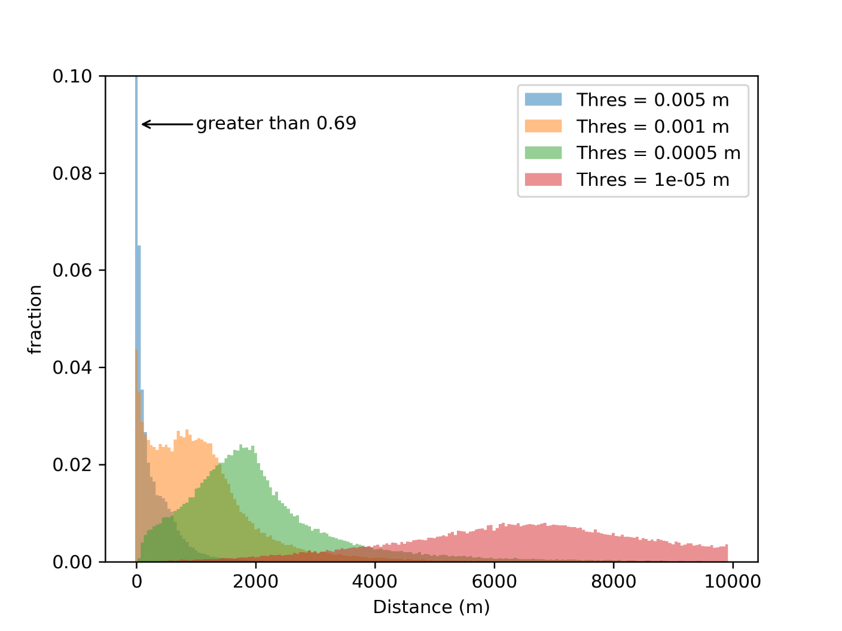
Figure 4: Theis equation Monte Carlo Results. The y-axis is truncated and the first bin of Thres=0.005 (blue) extends to greater than 0.69.

The Theis equation never reaches steady state. Instead, the cone of depression grows indefinitely, but at an exponentially decreasing rate. For the simulation here, the model was calculated for a time of ~10 years, which is considered sufficiently long to be at a minimal growth rate. A dh threshold is chosen where any value less than a threshold is considered unaffected by well pumping. What threshold to use isn’t readily clear and Figure 4 shows four potential values. When the value gets sufficiently large, such as for 0.005 m in figure 4, the results start to collapse into the first distance bin of the histogram. The y-axis of Figure 4 is truncated and nearly 70% of the results have a cone of depression less than 50 m. An arbitrarily small threshold, such as 1e-5 m, significantly extends the cone of depression towards the edge of the model domain (>10 km). While a very small threshold can likely be ruled out as aphysical, how large a threshold should be isn’t readily known, especially when a statewide characteristic length is the desired outcome. Choosing a single value of for the size of the cone of depression is a coarse estimation as the magnitude is highly dependent on the specific details of the sample location. Given this uncertainty, the cone of depression as taken to be either quite small (less than 50 m) or up to 2000 m.

Aquifer Mixing Distance
Advective and diffusive processes mix and homogenous an aquifer. How rapidly and over what length scales this occurs can also serve as an estimate for the area a single sample represents.
Diffusive processes can be ignored due to their slow rates of mixing. Molecular diffusion coefficients (D) of PFAS compounds from atmospheric temperature water are typically about 5x10⁻⁶ cm² / s (PFOA: 4.8x10⁻⁶ cm² / s; PFOS: 5.40x10⁻⁶ from Schaefer et al. 2019) but range over an order of magnitude depending on the compound. Smaller chain compounds tend to have faster diffusion than larger chain compounds. This distance of diffusion (L) over 30 years (t but in seconds) is only about 70 cm.
$$L=√(Dt)$$

Instead, advection is the main mixing mechanism for aquifers. Given the limited turbulence in uniform aquifer flow contamination tends to move as plug flow. But the distance the ground water moves suggests a distance over which a sample could be representative. A non-detect result should suggest that the aquifer upgradient of the sample is also free from the contaminate of concern.
We can estimate groundwater flow with the Darcy equation. Variability of subsurface properties makes it difficult to establish a representative distance that can be applied across the state. The rate of groundwater flow is primarily dependent on the hydraulic permeability (k), dynamic viscosity (μ), and hydraulic head gradient (Δh). Permeability varies over many orders of magnitude, and dynamic viscosity is affected by temperature and solute content. A Monte Carlo simulation, with 10⁶ solutions, is chosen to get a probability distribution function of groundwater flow. See Table 2 for parameter ranges.

Parameter | Minimum | Maximum
Hydraulic Gradient (Δh) | 10⁻⁵ | 10⁻²
Hydraulic Permeability (k) | 10⁻¹² cm² | 10⁻⁷ cm²
Dynamic Viscosity (μ) | 3x10⁻³ Pa s | 1x10⁻³ Pa s
Table 2: Parameters used in Darcy equation Monte Carlo simulation

The solution to the darcy equation is a velocity, which is then multiplied by 30 years to estimate a representative distance. 30 years is roughly the duration that PFAS has been present in the environment due to sludge spreading and is considered sufficiently low to have the estimate be conservative. The median of the result is 175 m. There is a long tail on the result with a maximum distance of more than 25000 m. There is a directionality to this distance, but as an initial estimate the distance is applied in all directions uniformly.
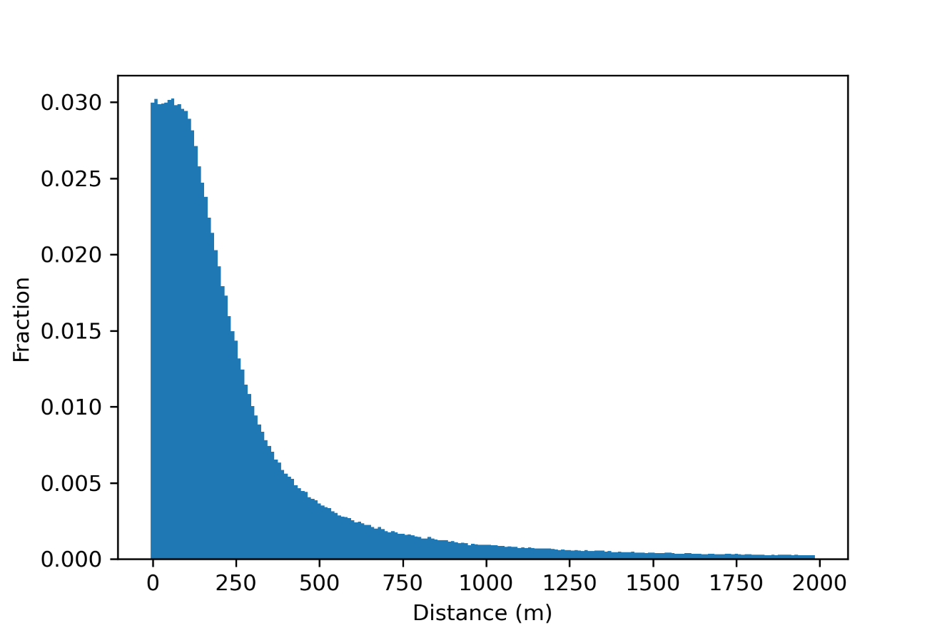
Figure 5: Darcy equation Monte Carlo Result. There is a long tail with a maximum distance of more than 25000 m.

The estimate of a statewide representative distance from the cone of depression is probably less than 50 m, but could be up to 2000 and the estimate from plug flow is about 100 to 200 meters. These two values can be additive with the final estimate between 200 and 2000 m.

[[use sand and gravel aquifer locations as the most mixed and the mostly likely to have broad representation of aquifer state]]
[[map showing where the ND would cover aerially, one using 200 m and 2000 m]]
[[map of locations furthest from known PFAS sources; LD1600 and landfills]]
[[find water samples in a atmospheric deposition bin that does not have a spreading field in the bin, and compare the probably of the depositional model to the observed PFAS concentrations]]
Schaefer, C.E., Drennan, D.M., Tran, D.N., Garcia, R., Christie, E., Higgins, C.P. and Field, J.A., 2019. Measurement of Aqueous Diffusivities for Perfluoroalkyl Acids. Journal of Environmental Engineering, 145(11). DOI: 10.1061/(ASCE)EE.1943-7870.0001585

